Report OS-2 Assignment – 5

EE17BTECH11041

Sumanth Reddy Cherupally

The output of the program demonstrates the following:

The same chopstick is not being used by two philosophers to eat at the same time.

No two adjacent philosophers are eating simultanously as they will have to share the chopstick.

The following is the required graph

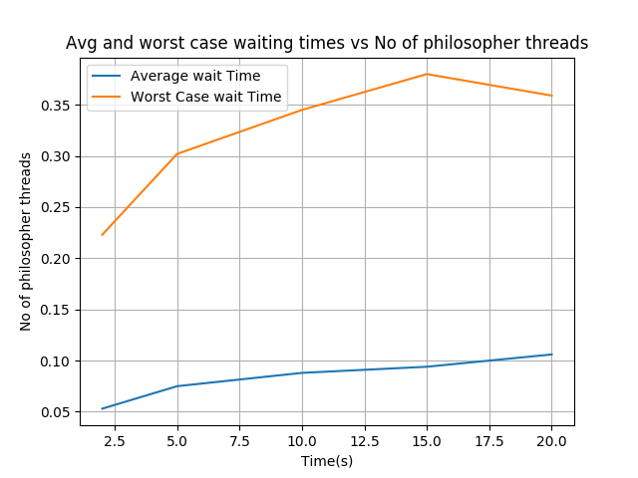

* As we can see the Average waiting times are much less than the worst case waiting times. This implies some threads are starving. As the number of threads increase the Average waiting time increases very slightly as well as the worst case waiting time also increases as expected.
* Because as the number of threads the waiting time will not change much more number of philosophers will not effect the occupancy of chopsticks and one chopstick can only acessed by two philosophers at any point of time.
* Worst case time will also not be affected much as the philosopfers sit on the roiund table and interfere only with activities of their neighbours irrespective of number of total philosophers.